Contact Us  For information about classroom music at Hillview or general enquiries, please contact Philippa Becker: p.becker@hillview.school.nz  For information about tuition in a specific instrument or involvement in a group at school, please contact the teacher involved.  For specific information about the Band Programme, please contact Maree Parr: mareeparr@gmail.com  Our Mission  To provide a quality education in a Christian environment where students can develop their God-given abilities  Our Vision  To grow young people who love God and impact others through service and leadership  Hillview Christian school  150 Wilsons Road  Ph: 3326 923 |  |  | Music Opportunities  Hillview Christian school

School-Based Programmes  Year 2 Choir – Mrs Dianne Somlyai  Mrs Somlyai has run junior choir for many years. She has a passion for music and loves to see children involved in music making. Mrs Somlyai is particularly skilled at spotting talent and giving children opportunities to develop confidence in their solo and group singing. She also develops students’ instrumental skills along with their singing. For more information please contact Mrs Somlyai on d.somlyai@hillview.school.nz.  Year 3-4 Choir – Mrs Kim Morgan  All Year 3-4 students are invited to join choir with Mrs Morgan. Mrs Morgan is a trained vocalist with years of experience in training vocal students as well as running and conducting choirs. She plays the piano and provides a warm and friendly singing experience for children. For more details please see Mrs Learey or Mrs Morgan.  Year 5-8 Choir – Mrs Kim Morgan  All Year 5-8 students are welcome to join the choir which is run by Kim Morgan. The students have the opportunity to participate in two festivals – the South Festival which was hosted here at Hillview last year, and the Christchurch Schools Music Festival. The choir also performs in school contexts such as assemblies. Contact Mrs Morgan for further information: k.morgan@hillview.school.nz  Year 7-10 A Capella Group– Anneliese Veronese  ** Limited spaces available** Students will learn how to hold a part in a small group, experience excellent vocal training, and will develop their musicianship and performance confidence. Students from 2017 have automatic entry to the group in 2018. Auditions for new students are to be held 9th Feb, 12:30pm in the bowling club. Applicants will need to sing one verse of the National Anthem (in English or Maori) unaccompanied. See Mrs Becker for further details: p.becker@hillview.school.nz  Year 7-10 Performance Band – Mr Frost and Mr Meecham  This is a wonderful opportunity for a group of talented musicians and singers to rehearse and perform on stage (usually at end-of-term assemblies). We usually meet on Thursday mornings at 8am and aim to finish around 8.35am. The aim is not just to develop gifts and talents but present songs that impact others through encouraging, comforting, and/or challenging lyrics. If you are interested in joining, see Mr Frost or Mr Meecham. |  |  | 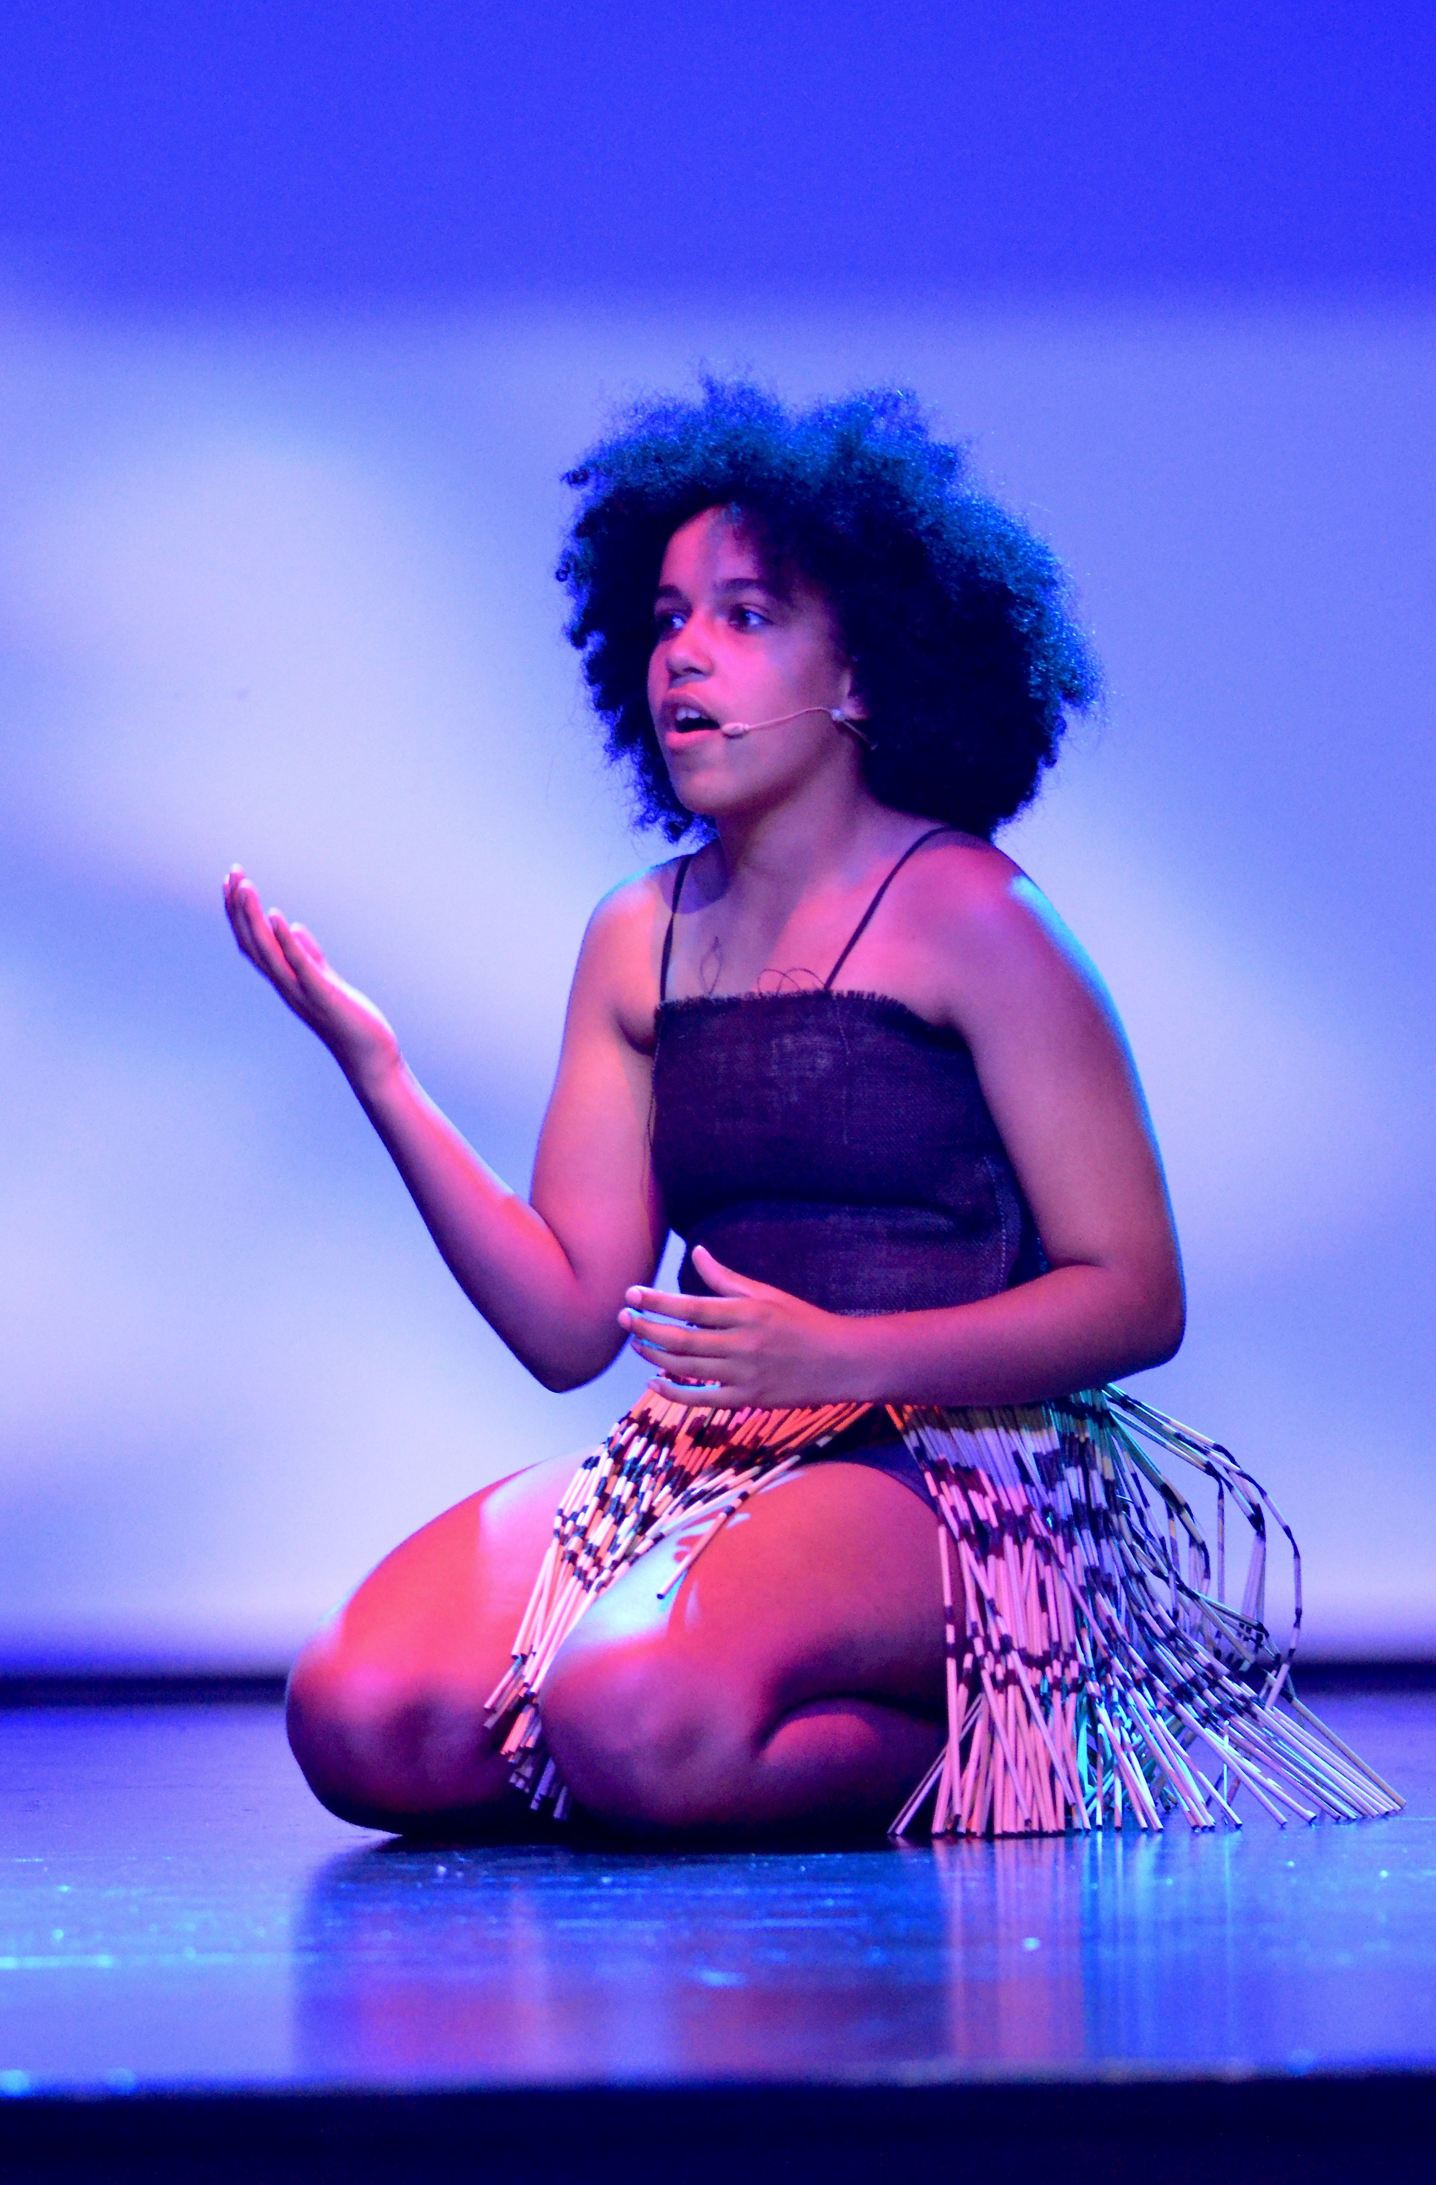
 |  |  | 5

How the Itinerant Programme Works
The itinerant programme is hosted and set up by the school, but parents enter into a private arrangement with the teacher regarding fees, payments, attendance, absences, lesson policies, terms, and other details. Itinerant lessons usually run through class time, although there may be lunchtime and after school options available depending on the particular teacher’s timetable.
Some teachers only take individual lessons whereas groups are on offer with others.

Pricing
- Pricing included here is for 2018 only.
- Please contact the teacher directly if pricing is not listed
- Contact Maree Parr directly for the band programme pricing.

Instrument Hire
Hillview has a small number of violins and flutes available for hire. Please contact David Mitchell for more information (d.mitchell@hillview.school.nz).

Other Performing Arts Opportunities

Kapa Haka
We are privileged to have specialist Kapa Haka teacher Steve Reid come to Hillview each week and teach Kapa Haka to our Year 4 – 10 students. The Kapa Haka group work towards performing in different school events as well as the Tuhono Kapa Haka Festival. Kapa Haka is optional for Year 7 students. Please talk with your child about their interest in joining Kapa Haka. Commitment for the year is essential to those who want to join. There will be a cost of $10 for the year to cover all Kapa Haka expenses, such as, uniform hire/care, Tuhono fees, and tuition. This will be added to your account.
For more information please contact Deb Owen: d.owen@hillview.school.nz

Hip-Hop Dance – Year 7-10
Sarah Taylor (our youth worker at Hillview) offered lunchtime hip-hop lessons in 2017 and these are on offer again in 2018. For more details please email Sarah: sarah@c3chch.org.

School Production – Year 7-10
The school usually produces a musical every second year. On the ‘off year’ we present an evening of dance, drama, and music on a given theme. Students from Years 7-10 are invited to audition for these performance opportunities.

Outreach Band Programme (Years 5-8)  Students may enroll in the band programme. This involves a one-hour band session as well as a private individual/group lesson.  Enquiries to Maree Parr (Band Programme Director) mareeparr@gmail.com  Instruments offered: flute, clarinet, saxophone, trumpet, trombone, bass guitar, percussion.  Bass Guitar Lessons – Chris Wethey (Bachelor of Musical Arts)  Students will learn to play music of their choice and develop the skills to play in a band. Lessons are recommended for Year 7s and above due to the size of the instrument.  $28 per 30 minutes (individual)  All enquiries to Chris Wethey on chriswethey@gmail.com Cell: 027 440 6990  Vocal Lessons – Anneliese Veronese (BMus)  Anneliese Veronese is part of Voices Co.. She is a classically trained vocalist, successful perfomer, and has a degree in contemporary singing. Anneliese is also passionate about music theory and is able to offer instruction in this area alongside singing technique.  - $30 per 30 minutes (individual lesson)  - $20 per 30 minutes (group lesson)  - $55 per 60 minutes (individual lesson)  - $35 per 60 minutes (group lesson)  All enquiries to Anneliese on veronese.singing@gmail.com |  |  | Guitar Lessons – Marcus Burton  - $20 per 25 minutes (individual) - $12 per 25 minutes (group – maximum of 3 students) All enquiries to Marcus Burton Cell: 027 543 1210 Email: marcus.warren.burton@gmail.com Marcus is in his last year of a Bachelor of Musical Arts at Ara School of Music. He takes is also offering contemporary guitar lessons for students at Hillview for the first time in 2018. Marcus not only plays a range of instruments, but is passionate about song writing.  Violin Lessons – Milana Kornieko  Milana is associate principal second violinist with the Christchurch Symphony Orchestra and offers violin lessons to all ages.  - Tuesdays from 8:30am  - $25 per half hour (individual)  Phone: 384 7864 or 027 2000 816 Email: milana_sausage2@hotmail.co  All enquiries to Milana  Piano Lessons – Yvonne Tikao (ATCL)  Yvonne offers lessons in piano, keyboard and theory tuition. Classical to modern. Lessons are given before, during, or after school. Piano and theory exams are also offered.  Individual lessons $30 per half hour  All enquiries to Yvonne  Cell: 027 356 6462 Phone: 388 3360 Email: Yvonne.tikao@xtra.co.nz  Drum Lessons  We have an amazing new drum teacher at Hillview Cameron Finlay attends Grace Vineyard and is very involved in the music scene in Christchurch as a member of four bands. He plays drums, keyboard, bass, guitar, and performs lead vocals. Cam is also an accomplished song writer. On offer are 20 minute one on one lessons - $170 incl gst per term ($17 per lesson). This is for a 10 week term - price adjusts accordingly if term is longer or shorter than 10weeks. Parents are able to pay via Cheque, Direct Credit (internet banking), Bank deposit or Cash.  All enquiries to admin@velocitymusicschool.co.nz  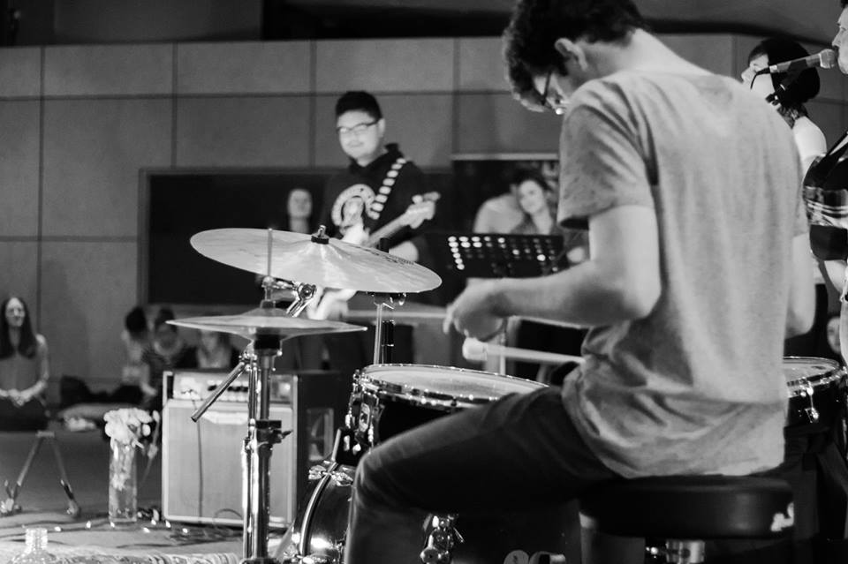
Milana is a violinist with the Christchurch Symphony Orchestra and offers violin lessons to all ages. For violin hire contact David Mitchell: d.mitchell@hillview.school.nz. The school has a limited number available.
Contact:

Piano Lessons – Yvonne Tikao (ATCL)
Yvonne offers lessons in piano, keyboard and theory tuition. Classical to modern. Lessons are given before, during or after school. Piano and theory exams are also offered.
Phone: 389 3459 or 027 356 6462

